**Source: ORANGE**

**Title: Report on ATeMPO_SPINE round-robin tests conducted at Orange**

**Document for: Information**

## Agenda Item: 10.5

This document is a re-submission of S4-AHQ101.

1. Background

The objective of the present document is to document how round robin tests following the test plan in [1] were conducted in the Orange Lab test facility.

1. Tests at Orange Lab according to the test plan

Tests were conducted at the Orange Lab premises in Lannion, France. They were split in two time periods:

* In a first time period (in Weeks 27-28) testing with the 4.1 loudspeaker method was performed - the limited time frame was not sufficient to perform testing with the new 8-loudspeaker method specified in TS 103 224, however binaural noises from TS 103 224 were used with the 4.1 loudspeaker method.
* A second time period (in Week 37) was allocated to be able to perform tests with the 8-speaker method.

As described in [2], the basis was to measure S-MOS, N-MOS and G-MOS for the ETSI ES 103 106 quality predictor in various conditions.

The complete list of background noise conditions described in [1] was evaluated:

- 8-speaker method (ETSI TS 103 224)

- 4.1 loudspeaker method (ETSI ES 202 396-1)

- 4.1 loudspeaker method using the same noise scenarios as in TS 103 224, for HHHF

Not all DUT positions and bandwidth described in the test plan in [1] could be tested due to time and resource restrictions. More specifically:

* For the DUT position only the “hand-held handsfree” case (6 noise types plus silence) was considered and the table “desktop handsfree” case (one noise type plus silence) was not tested.
* For bandwidths (UMTS CS call used), only wideband was considered and narrowband was not tested.

An acoustically treated room was used. This room is used to conduct all GSMA HD voice logo certification testsby Orange; the reproducibility of test results for ES 202 396-1 has been already validated with several labs worldwide performing self-certification*.*

HEAD acoustics ACQUA with the HAE-BGN and 3PASS background noise systems were used. Loudspeakers were Genelec 1029 A (loudspeakers 1 to 4), Foxtex PM0,5sub (subwoofer) and Fostex PM0,5n (loudspeakers 5 to 8). The test sequences and (smd) script files to execute the tests were provided by HEAD Acoustics [3].

A HEAD Acoustics HATS was used to allow comparison with other labs using the same HATS model and minimize sources of variation in the round robin tests.

**Procedure**

The mouth simulator of the HATS was calibrated at MRP (80 to 10000 Hz) using a ¼-inch pressure-field microphone (B&K 4938).

The HFRP calibration was performed for one measurement distance (50 cm).

The HATS ears were calibrated.

Equalization of the 4.1 speaker system, adhoc delays (optimized experimentally to keep equalization gains within reasonable limits) were used:

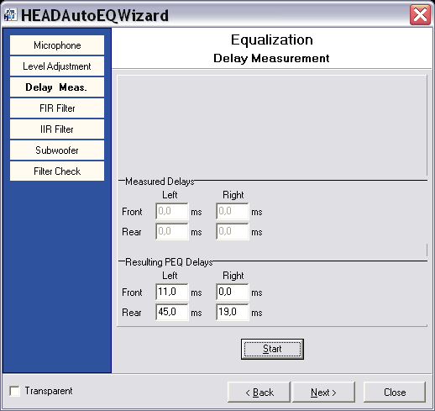

Equalization of the 8 speaker system for hand-held handsfree was done automatically with 3PASS.

1. Additional tests (beyond the test plan in [1])

Some additional tests were conducted;

* The test plan in [1] required to test 6 devices (DUT1 to DUT6) that were the same for all labs involved in the round robin activity. An extra device (DUT7) was included in all tests.
* For all test cases (in sending direction), the audio from the DUT was recorded to allow informal subjective listening and verify the consistency between objective and subjective scores.
* For the 8-loudspeaker method (HHHF case), tests were conducted twice (with and without 22.5 ° rotation of HATS) to check whether the HATS rotation with respect to loudspeakers has any impact. Furthermore, tests with no HATS rotations were also repeated twice to verify if there is any variability - in the following only test results for the first trial are reported as the differences in MOS-LQO are in the +/-0.1 range.

1. Physical test setup for the tests in the sending direction

The test room dimensions are 5m (length) x 3,67m (width).

**HATS position**

HRP 143,5 cm above the floor

The HATS was placed 2,59m from the front wall and 1,86m from the right wall.

HATS rotated by 0° or 22.5° - the latter case was similar to [2] to avoid obstructing the sound from speaker 7.

**Speaker position**

The speaker height and placement are summarized in Table 1.

Table 1. Loudspeaker position in the test room.

|  |  |  |  |  |  |
| --- | --- | --- | --- | --- | --- |
| **Loudspeaker** | **Left wall** | **Front wall** | **right wall** | **back wall** | **Height** |
| **1 - Front left** | **0,53 m** | **1,3 m** |  |  | **1,36 m** |
| **2 - Front right** |  | **1,25 m** | **0,59 m** |  | **1,36 m** |
| **3 - Rear right** |  |  | **0,68 m** | **1,06 m** | **1,36 m** |
| **4 - Rear left** | **1,09 m** | **0,68 m** |  |  | **1,36 m** |
| **5-** |  | **1,17 m** |  | **2,30 m** | **1,23 m** |
| **6-** |  |  | **0,42 m** | **2,30 m** | **1,23 m** |
| **7-** |  |  | **1,86 m** | **0,80 m** | **1,23 m** |
| **8-** | **0,42 m** |  |  | **2,30 m** | **1,21 m** |

**Equalization of the 4.1 speaker method (ES 202 396-1)**

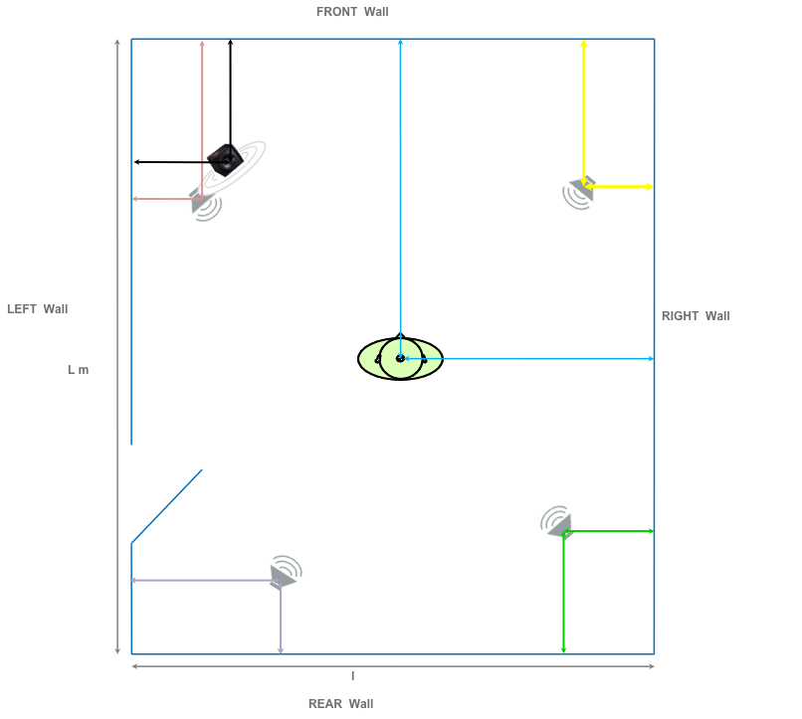

**Equalization of the 8-speaker method (TS 103 224) for the hand-held handsfree mode**

The same positions were used in the 8-loudspeaker case, except that 4 loudspeakers were added in the room and the HATS was rotated by either 0° or 22.5°. The loudspeaker numbering was the same as in [2] except that loudspeakers 3 and 4 (rear) were swapped.

1. Equalization results
   1. Hand-held handsfree equalization results (8 speaker method)

Only equalization results for no HATS rotation are shown here, however equalization results for the 22.5° rotation case are also available if needed.

Diagrams of validation results

|  |  |
| --- | --- |
| Calibration Position | Fine tuning position |
| Frequency Response I | 50 Hz to 10000 Hz |
|  |  |
| Frequency Response II | 10000 Hz to 16000 Hz |
|  |  |
| Average Frequency Response | 50 Hz to 20000 Hz |
|  |  |
| Mag. of Complex Coherence | 100 Hz to 1000 Hz |
|  |  |
| Phase of Complex Coherence I | 100 Hz to 1000 Hz |
|  |  |
| Phase of Complex Coherence II | 1000 Hz to 1500 Hz |
|  |  |

* 1. Equalization results for the 4.1 speaker method (ES 202 396-1)

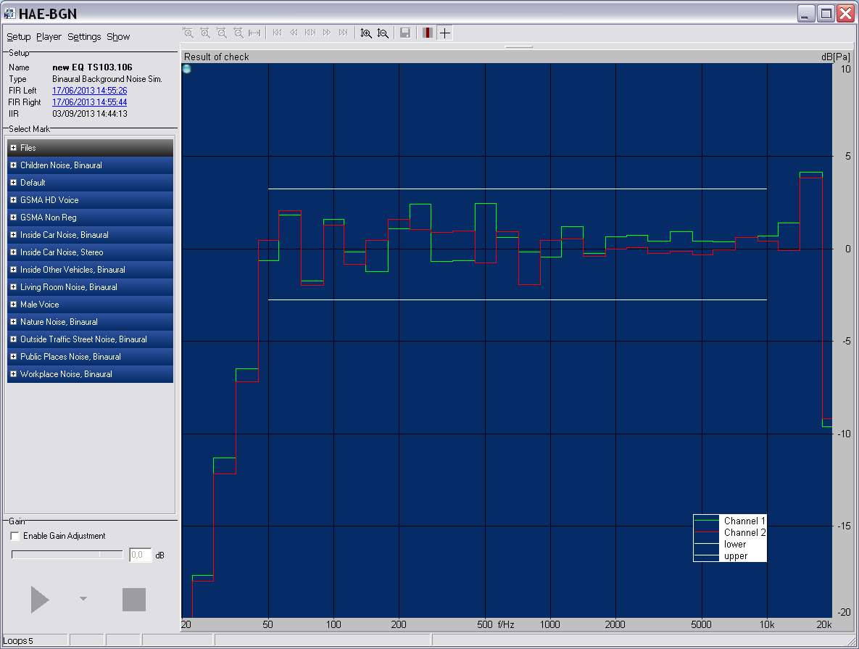

* 1. Mouth equalization results

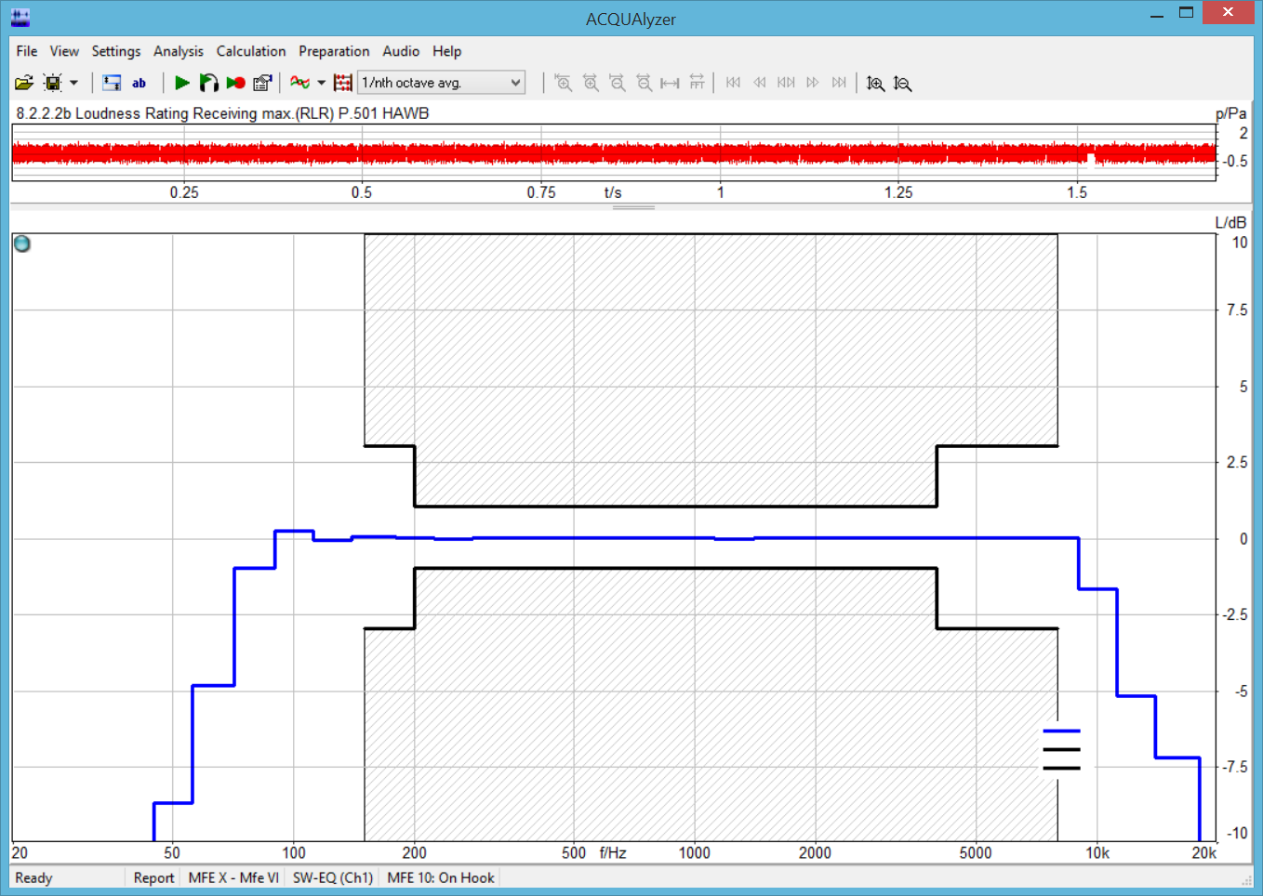

1. Additional positioning information for the ES 103 224 method

The positioning was made according to the testing procedure documented in [3].

1. Test results

As noted in [2], the detailed results will be available all labs have completed their measurements and the differences between the background noise methods can be analyzed using the same noise scenarios for the HHHF mode.

Results from the two noise generation methods were very close when using the same noise scenarios (from TS 103 224) as shown in Table 2.

Table 2. MOS-LQO values for TS 103 224 (no HATS rotation) minus MOS-LQO values for ES 202 396-1 with noise scenarios from TS 102 224.

|  |  |  |  |  |  |  |
| --- | --- | --- | --- | --- | --- | --- |
|  | **Pub** | **Crossroad** | **Trainstation** | **Inside Car** | **Cafeteria** | **Office** |
| S-MOS |  |  |  |  |  |  |
| DUT1 | 0,1 | 0 | 0 | 0 | 0,1 | 0 |
| DUT2 | -0,1 | -0,1 | 0 | -0,1 | -0,1 | 0 |
| DUT3 | 0 | -0,1 | 0 | -0,1 | -0,1 | 0 |
| DUT4 | -0,3 | -0,1 | -0,1 | 0 | -0,1 | 0 |
| DUT5 | 0,2 | 0,1 | 0 | 0 | 0,2 | 0,1 |
| DUT6 | -0,3 | -0,1 | -0,1 | 0 | -0,2 | -0,1 |
| DUT7 | -0,4 | 0 | 0 | 0 | -0,1 | -0,2 |
| N-MOS |  |  |  |  |  |  |
| DUT1 | 0 | -0,1 | -0,1 | -0,1 | 0 | 0 |
| DUT2 | -0,1 | -0,1 | -0,2 | -0,1 | -0,2 | -0,2 |
| DUT3 | 0 | -0,3 | 0 | -0,2 | -0,2 | -0,3 |
| DUT4 | 0 | -0,1 | -0,1 | -0,1 | 0 | -0,3 |
| DUT5 | 0 | -0,1 | 0 | -0,1 | -0,2 | -0,3 |
| DUT6 | -0,1 | 0 | 0 | -0,2 | -0,1 | -0,1 |
| DUT7 | -0,1 | -0,1 | -0,2 | -0,1 | -0,1 | -0,1 |
| G-MOS |  |  |  |  |  |  |
| DUT1 | 0 | 0 | 0 | -0,1 | 0 | 0 |
| DUT2 | -0,1 | -0,1 | -0,1 | -0,1 | -0,1 | -0,1 |
| DUT3 | -0,1 | -0,1 | -0,1 | -0,2 | -0,1 | -0,1 |
| DUT4 | -0,2 | -0,1 | 0 | 0 | -0,1 | -0,2 |
| DUT5 | 0,1 | 0 | 0 | -0,1 | 0 | 0 |
| DUT6 | -0,2 | -0,1 | 0 | 0 | -0,2 | -0,2 |
| DUT7 | -0,3 | -0,1 | -0,1 | 0 | -0,1 | -0,2 |

These results are illustrated in the figures below.

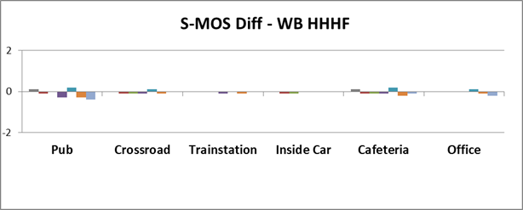

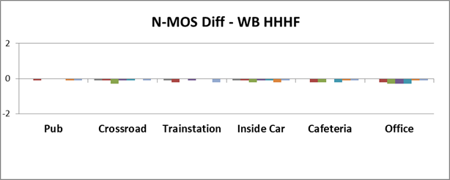

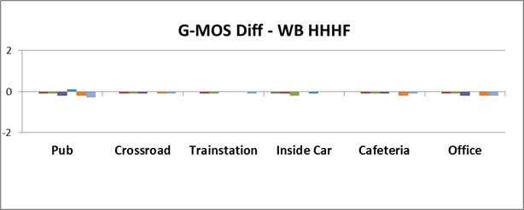

Comparison of test methods for HHHF for wideband (MOS values for TS 103 224 minus MOS values for ES 202 396-1 with noise scenarios from TS 102 224). For each noise scenario, the DUTS are plotted in sequence DUT1, DUT2…DUT7. Absolute values ranged from 2.3 to 4.2 (S-MOS), 1.7 to 3.5 (N-MOS) and 1.7 to 3.4 (G-MOS) for the TS 103 224 method.

Similarly, a comparison of test results between 0° and 22.5° HATS rotation is provided in Table 3.

Table 3. MOS-LQO values for TS 103 224 (no HATS rotation) minus MOS-LQO for TS 103 224 (22.5° HATS rotation) with noise scenarios from TS 102 224.

|  |  |  |  |  |  |  |
| --- | --- | --- | --- | --- | --- | --- |
|  | **Pub** | **Crossroad** | **Trainstation** | **Inside Car** | **Cafeteria** | **Office** |
| S-MOS |  |  |  |  |  |  |
| DUT1 | 0,1 | 0 | 0 | 0 | 0,1 | 0 |
| DUT2 | 0 | -0,2 | -0,1 | -0,1 | 0 | 0,1 |
| DUT3 | 0 | -0,1 | 0 | -0,1 | -0,1 | 0 |
| DUT4 | -0,3 | -0,1 | -0,1 | 0 | -0,1 | 0 |
| DUT5 | 0,4 | 0 | 0,2 | 0 | 0,1 | 0,1 |
| DUT6 | -0,1 | 0 | 0 | 0,1 | 0 | 0 |
| DUT7 | -0,4 | 0 | 0 | -0,1 | 0 | -0,1 |
| N-MOS |  |  |  |  |  |  |
| DUT1 | -0,1 | -0,1 | -0,1 | -0,1 | 0 | 0 |
| DUT2 | -0,3 | -0,2 | -0,3 | -0,3 | -0,3 | -0,3 |
| DUT3 | -0,1 | -0,3 | 0 | -0,2 | -0,2 | -0,3 |
| DUT4 | 0 | 0 | -0,1 | -0,1 | 0 | -0,1 |
| DUT5 | -0,1 | -0,1 | 0 | 0 | -0,1 | -0,1 |
| DUT6 | -0,1 | 0 | 0 | -0,1 | 0 | 0 |
| DUT7 | -0,2 | -0,2 | -0,2 | -0,2 | 0 | 0 |
| G-MOS |  |  |  |  |  |  |
| DUT1 | 0 | 0 | 0 | -0,1 | 0 | 0 |
| DUT2 | -0,1 | -0,3 | -0,2 | -0,2 | -0,1 | 0 |
| DUT3 | -0,1 | 0 | 0 | -0,2 | 0 | 0 |
| DUT4 | -0,2 | 0 | 0 | 0,1 | -0,1 | -0,1 |
| DUT5 | 0,2 | 0 | 0,1 | -0,1 | 0 | 0,1 |
| DUT6 | 0 | 0 | 0 | 0,1 | 0 | -0,1 |
| DUT7 | -0,4 | -0,1 | -0,1 | -0,1 | -0,1 | -0,1 |

1. Conclusions from the tests

The detailed conclusions about lab-to-lab variability will be drawn when results from all labs will be made available and analyzed.

The following preliminary observations can be made for the tests conducted in Orange:

* Similar to [2], both background noise methods produced almost identical hand-held handsfree results (averaged over noise types) and both methods use multiple speakers with highly correlated signals.
* MOS results averaged over noise scenarios were very similar between the two methods. The same observation can be made when checking the influence of 0° vs. 22.5° HATS rotation for the 8-loudpeaker case.
* Testing with the 3PASS system (TS 103 224) proved to be sometimes unstable and some test cases had to be repeated several times.
* Results from informal listening indicated that the MOS-LQO scores do not always represent perceived quality.

1. References

[1] Tdoc SQ-AHQ099, Proposed test plan for a Round Robin Test for comparison of background noise simulations – Rev. 1, Source: Editor (Qualcomm)

[2] S4-151040, ATeMPO_SPINE round-robin tests conducted at Sony, Source: Sony Mobile Communications

[3] Head Acoustics documentation provided for round robin

[4] ETSI ES 202 396-1, Speech quality performance in the presence of background noise; Part 1: Background noise simulation technique and background noise database

[5] ETSI TS 103 224, A sound field reproduction method for terminal testing including a background noise database